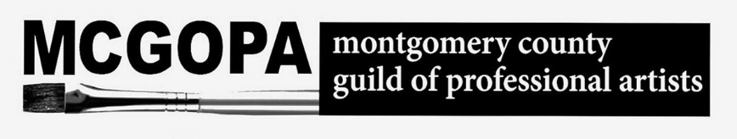

*The following signed Waiver MUST accompany your art if they are to be installed at The 431 Gallery.*

I, _____________________________, understand that MCGOPA, its officers and associates, The Upper Merion Community Center and Upper Merion Township Parks and Recreation Department hold no responsibility for my photographs being kept and displayed in the Artist Equity Show at the 431 Art Gallery from Thursday, May 25, 2025 to Wednesday, July 16, 2025.

I hold MCGOPA, The Upper Merion Community Center and Parks and Recreation Department harmless in the event that any damage should occur from this public presentation of my work.

_______________________________ ________________

Signed Date