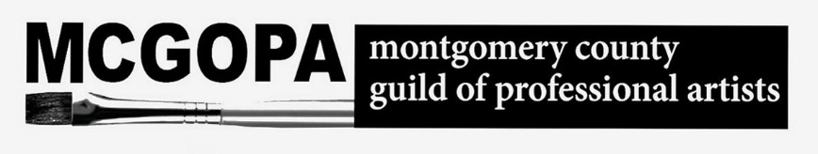

**The 431 Art Gallery**

At Upper Merion Township Community Center

431 West Valley Forge Road

King of Prussia, Pa. 19406

Home of MCGOPPA – The Montgomery County Guild of Professional Artists

[www.mcgopa.org](http://www.mcgopa.org)

*The Montgomery County Guild of Professional Artists (MCGOPA) has provided a platform for artists to*

*exhibit their work since 1988. A non-profit artists’ cooperative group, MCGOPA educates the public about*

*the visual arts and offers professional collaboration and support to working artists in Montgomery County*

*and beyond. In 2017 MCGOPA was awarded a generous grant from the Upper Merion Township Board*

*of Community Assistance which allowed the guild to establish the 431 Art Gallery in the new Upper*

*Merion Community Center in partnership with Upper Merion Township Parks and Recreation Department*

*And the upper Merion Community Center.*

**Guidelines for exhibiting at the 431 Art Gallery:**

(All artwork shown at 431 Gallery is Two-Dimensional)

* WEIGHT OF WORK MUST NOT EXCEED 12 POUNDS
* Artwork must be framed and wired and ready to hang.

Wire should be taught and secure on the frame.

* All work must be wired so as to be compatible with the exhibition hanging system of adjustable picture rails, rods and hooks.
* Artwork MUST have the following identification on the back:

Artist’s Name/Phone #/Title/Medium/Price

* All artwork should also have a tag with same information facing forward from the art for ease in labelling.
* MCGOPA Associates will assist in hanging. You must have representatives from your organization to help hang.
* If work is at Max 12 pounds, it must be hung from a re-enforced rail. MCGOPA Associate will assist with this.
* Work can be as large as 48” Wide by 60” High.
* The Gallery has the capacity of hanging 60 pieces. Along with the wall space, MCGOPA has a locked glass case.
* There is a glass case at the top of the stairs. There are three levels in this case and can be used for smaller 2D work. The size of this case is 48” wide and 66” high.
* MCGOPA does not accept Nudes, Religious, or Political themes for subject matter.

***For exhibits that are arranged outside of MCGOPA’s group shows, exhibiting artists are expected to manage, design, and install their own shows. MCGOPA Associates can help with hanging. Exhibit dates (art drop-off, installation, any events/receptions, and artwork pick-up) need to be approved through MCGOPA with the Community Center. MCGOPA will work with our liaison at the community center to book these dates on your behalf. MCGOPA will post news of your exhibition on MCGOPA.org and on MCGOPA’s social media platforms. MCGOPA will manage sales and retain 30% of sales and 20% for MCGOPA Associates in the show. At this time no commission on sales is retained by the UM Community Center.

Note: Because this is a community center open to the members and public, there is no alcohol allowed during an event or reception.

For views of the gallery, please visit: [www.mcgopa.org](http://www.mcgopa.org) and click on “New Associates” at the top menu.

The dates for the AE Show.

DROP OFF:   Thursday, May 2025, between 11:30 am and 12:00 pm

RECEPTION:  Sunday, May 18, 2025, from 2:00 pm to 4:00 pm

PICK-UP DATE:  Wednesday, July 16, 2025 from 10:00 am to 11:00 am

The waiver is filled out with dates for AE's show and attached.

The copy of the updated guidlines is attached.

I am **not** attaching the copy of the walls picture.

**Deborah Northey**

[www.debnorthey.com](http://www.debnorthey.com/)